Summary of Results: Age Cohort Experiment

Proportion of bees with dye present:
3.73% (257 lines of data) of data points were removed for disagreements in whether dye was present.
The AP23 treatment was significantly higher than the negative and consumption controls, and the positive control had the highest proportion of bees with dye.
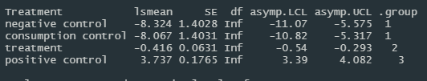
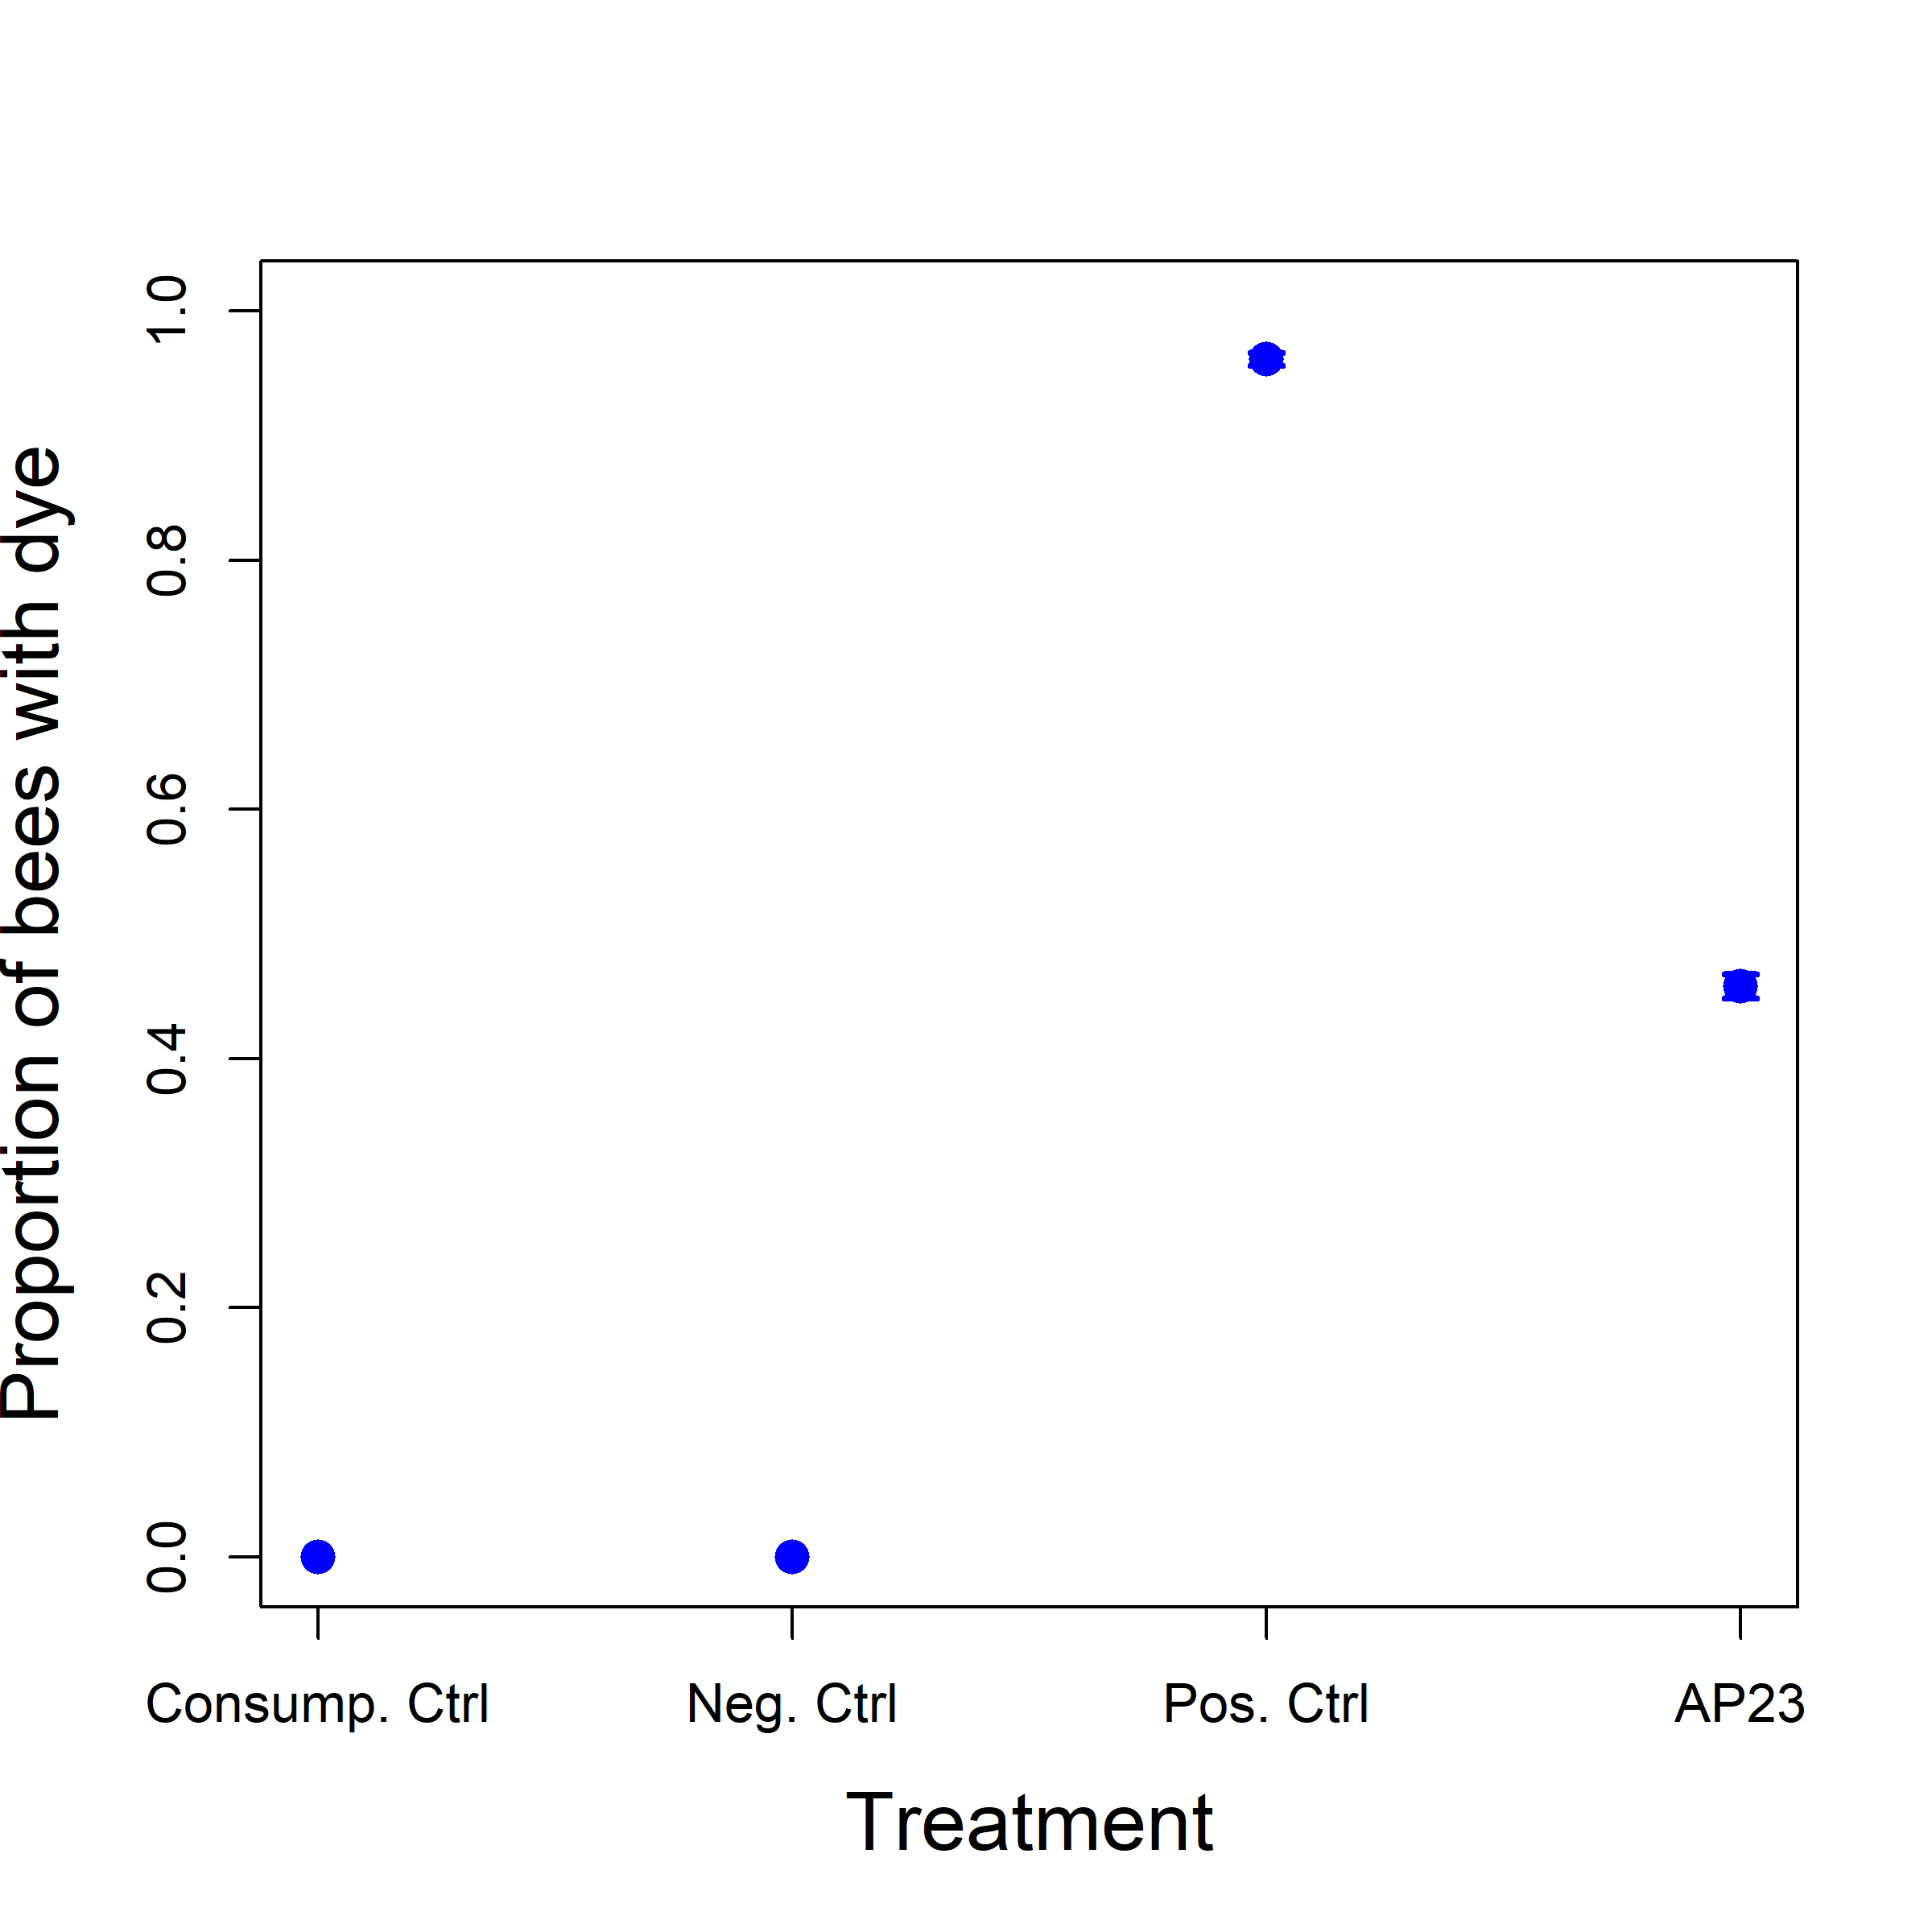
Figure 1: Proportion of bees with dye observed in their gut. Standard errors are extremely small since we are averaging these across 1,000 + samples, but they are there.
I then subset to only analyze the treatment (AP23) and find a significant effect of the sample day:
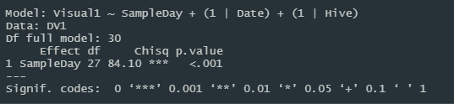
It was significant. For this experiment, we can use multiple comparisons to look at differences between each individual day. Mind they are in order by ascending means, not number.
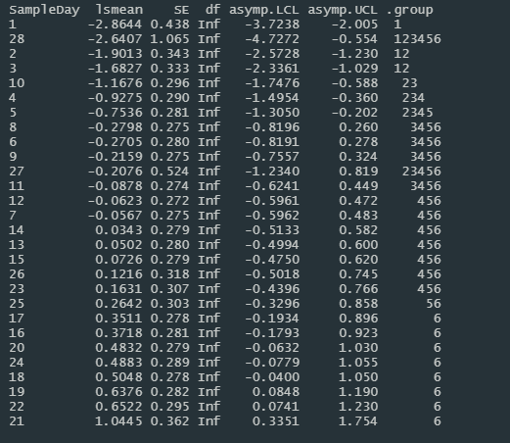
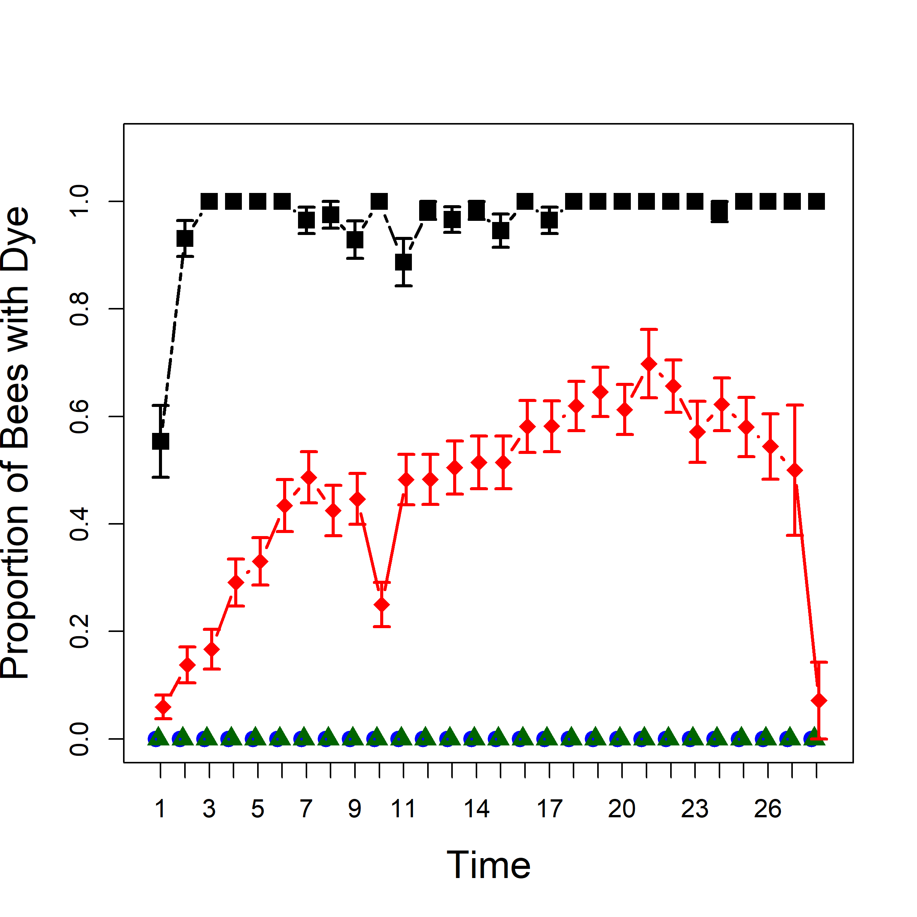
Figure 2: The proportion of bees with dye in their guts. Blue and green lines are the negative and consumption controls. Neither control had any dye recovered. Red line: AP23 treatment with dye. Black: fondant positive control. Dots and bars represent means and standard error.

We can visualize the model output for just the treatment. 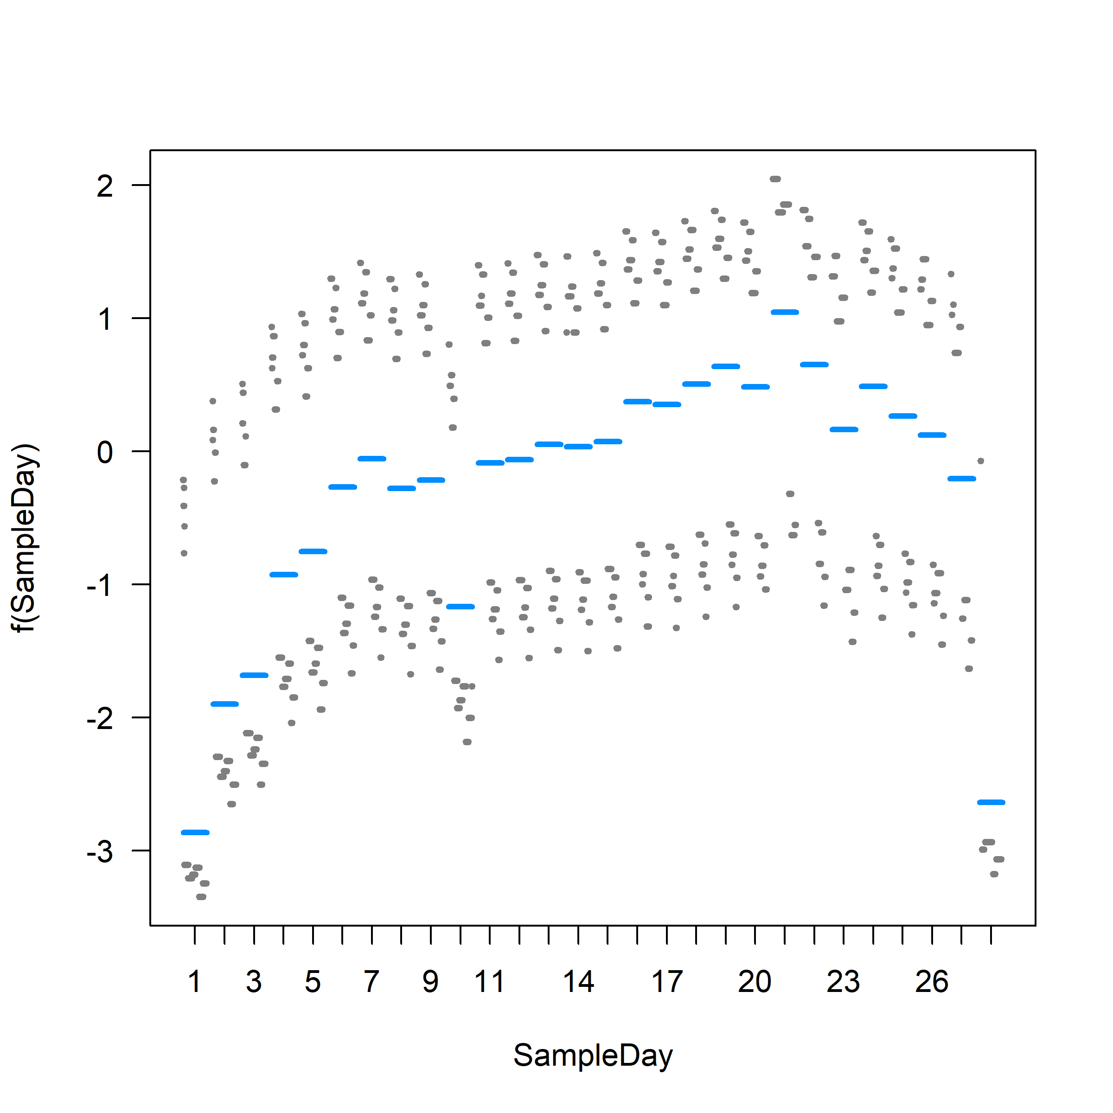
Figure 3: If we treat the sample day as a factor, we see a similar graph as shown above. Here, we are visualizing a regression model, not the actual means for the data. What is important is that this takes our entire model into consideration (though for this response variable we only had the effect of hive as an addition to the model).

Number of bees observed:

The positive and negative controls and the treatment were significantly different from the consumption control, but not each other:
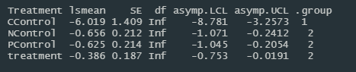
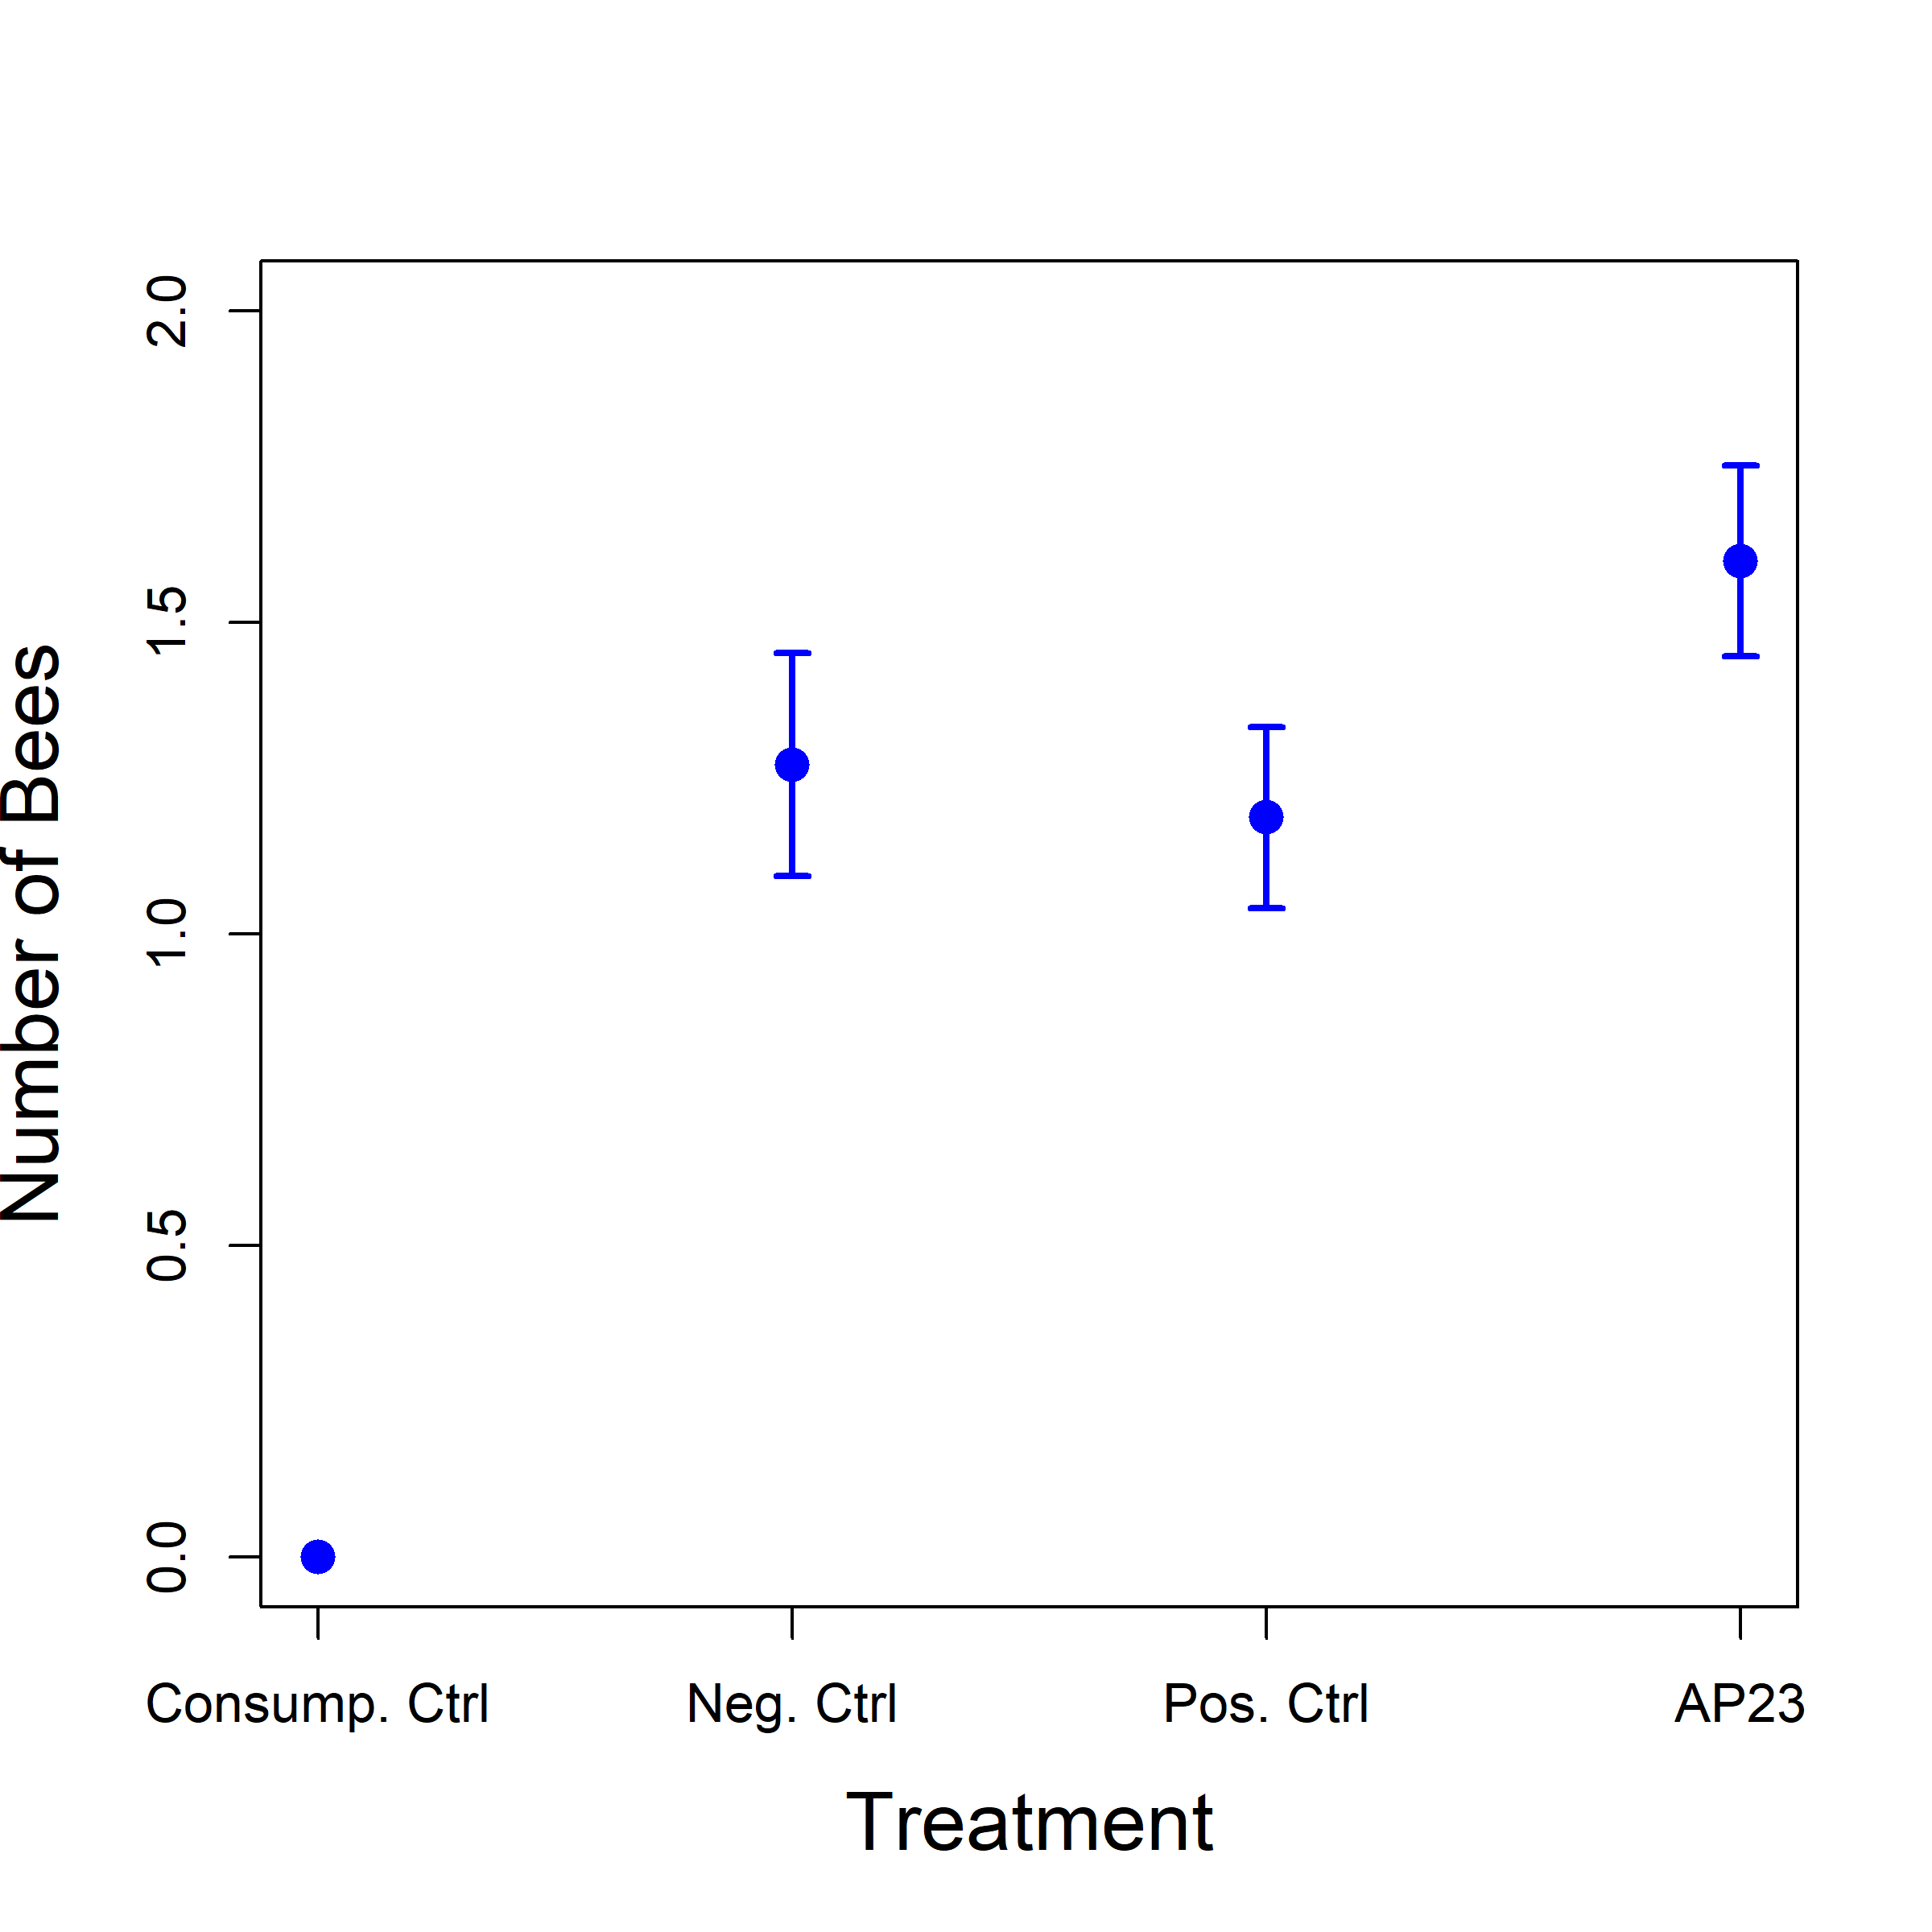
Figure 4: Average number of bees observed on food. Means and SE are shown for each treatment.

I then subset to only analyze the treatment (AP23) and find a significant effect of the sample day:
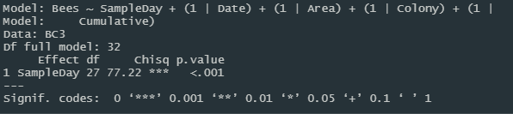
But multiple comparisons do not show any differences when comparing all 28 days to each other. This is likely due to lower power in the multiple comparisons vs the overall model. So, how do we identify which days have more or less bees counted without comparing all days one by one?

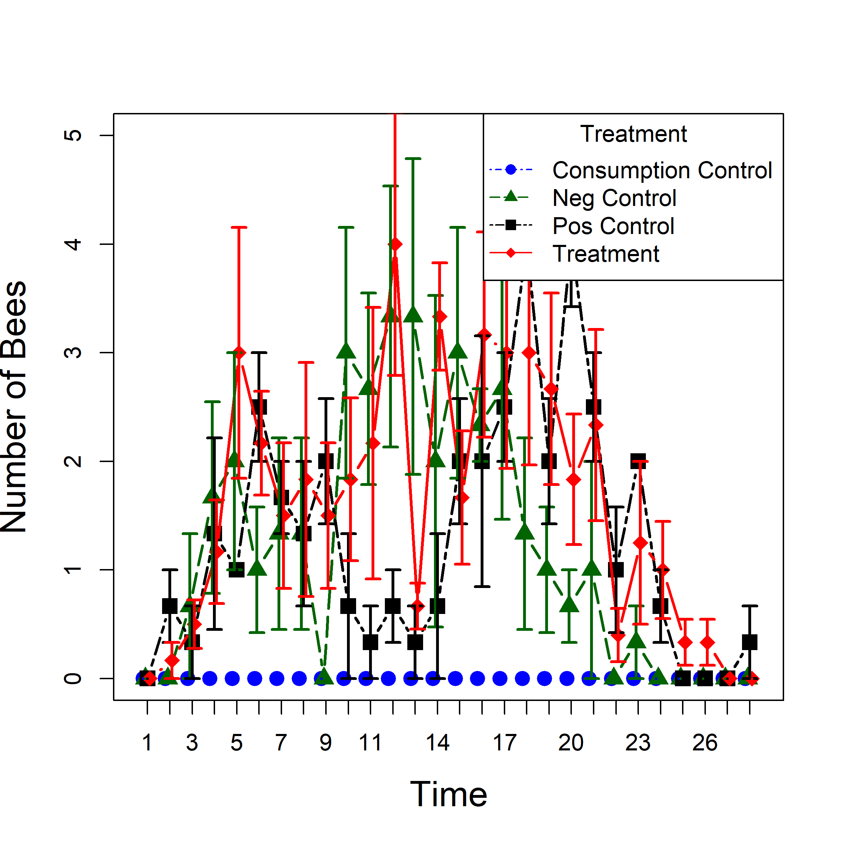
Figure 5: An absolute mess of a figure. There is no way to show all treatments on one graph. See below for separate graphs for each treatment. Blue – consumption control is all 0, so no graph will be made for it.

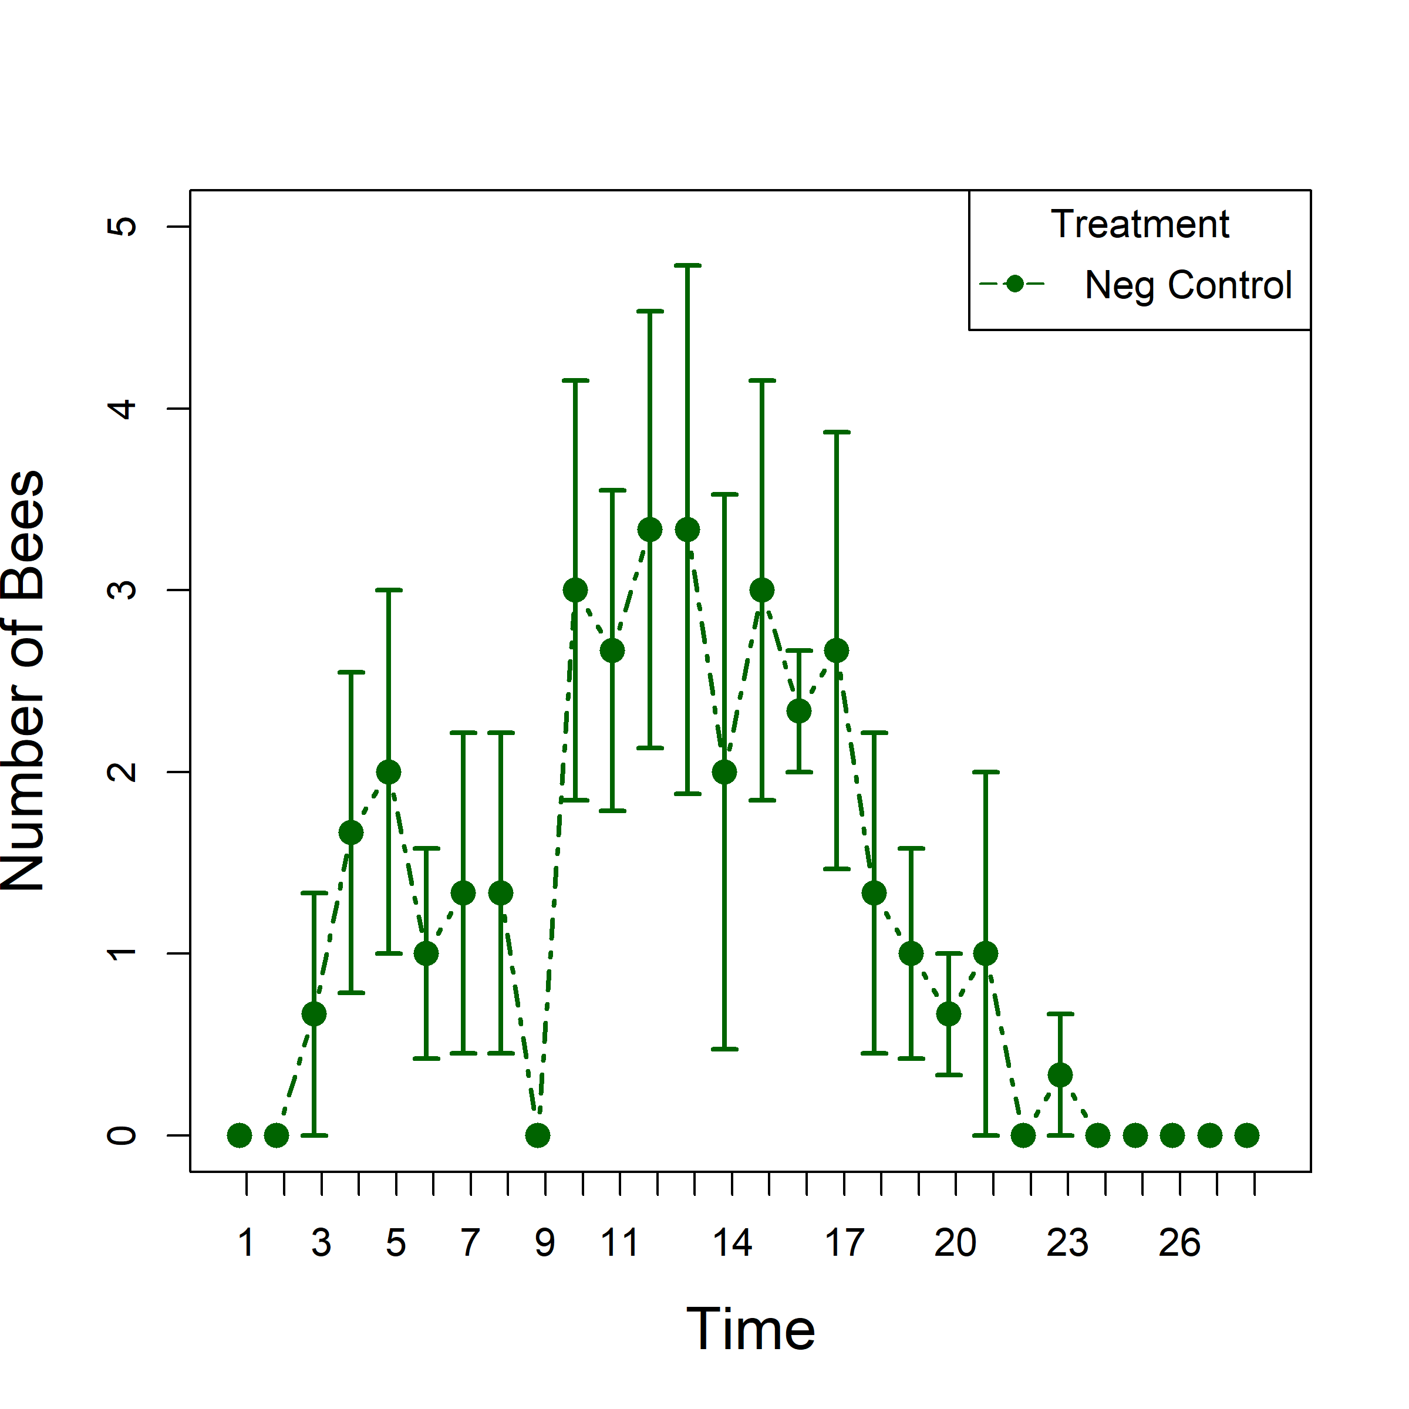
Figure 6: Negative control for the number of bees observed.

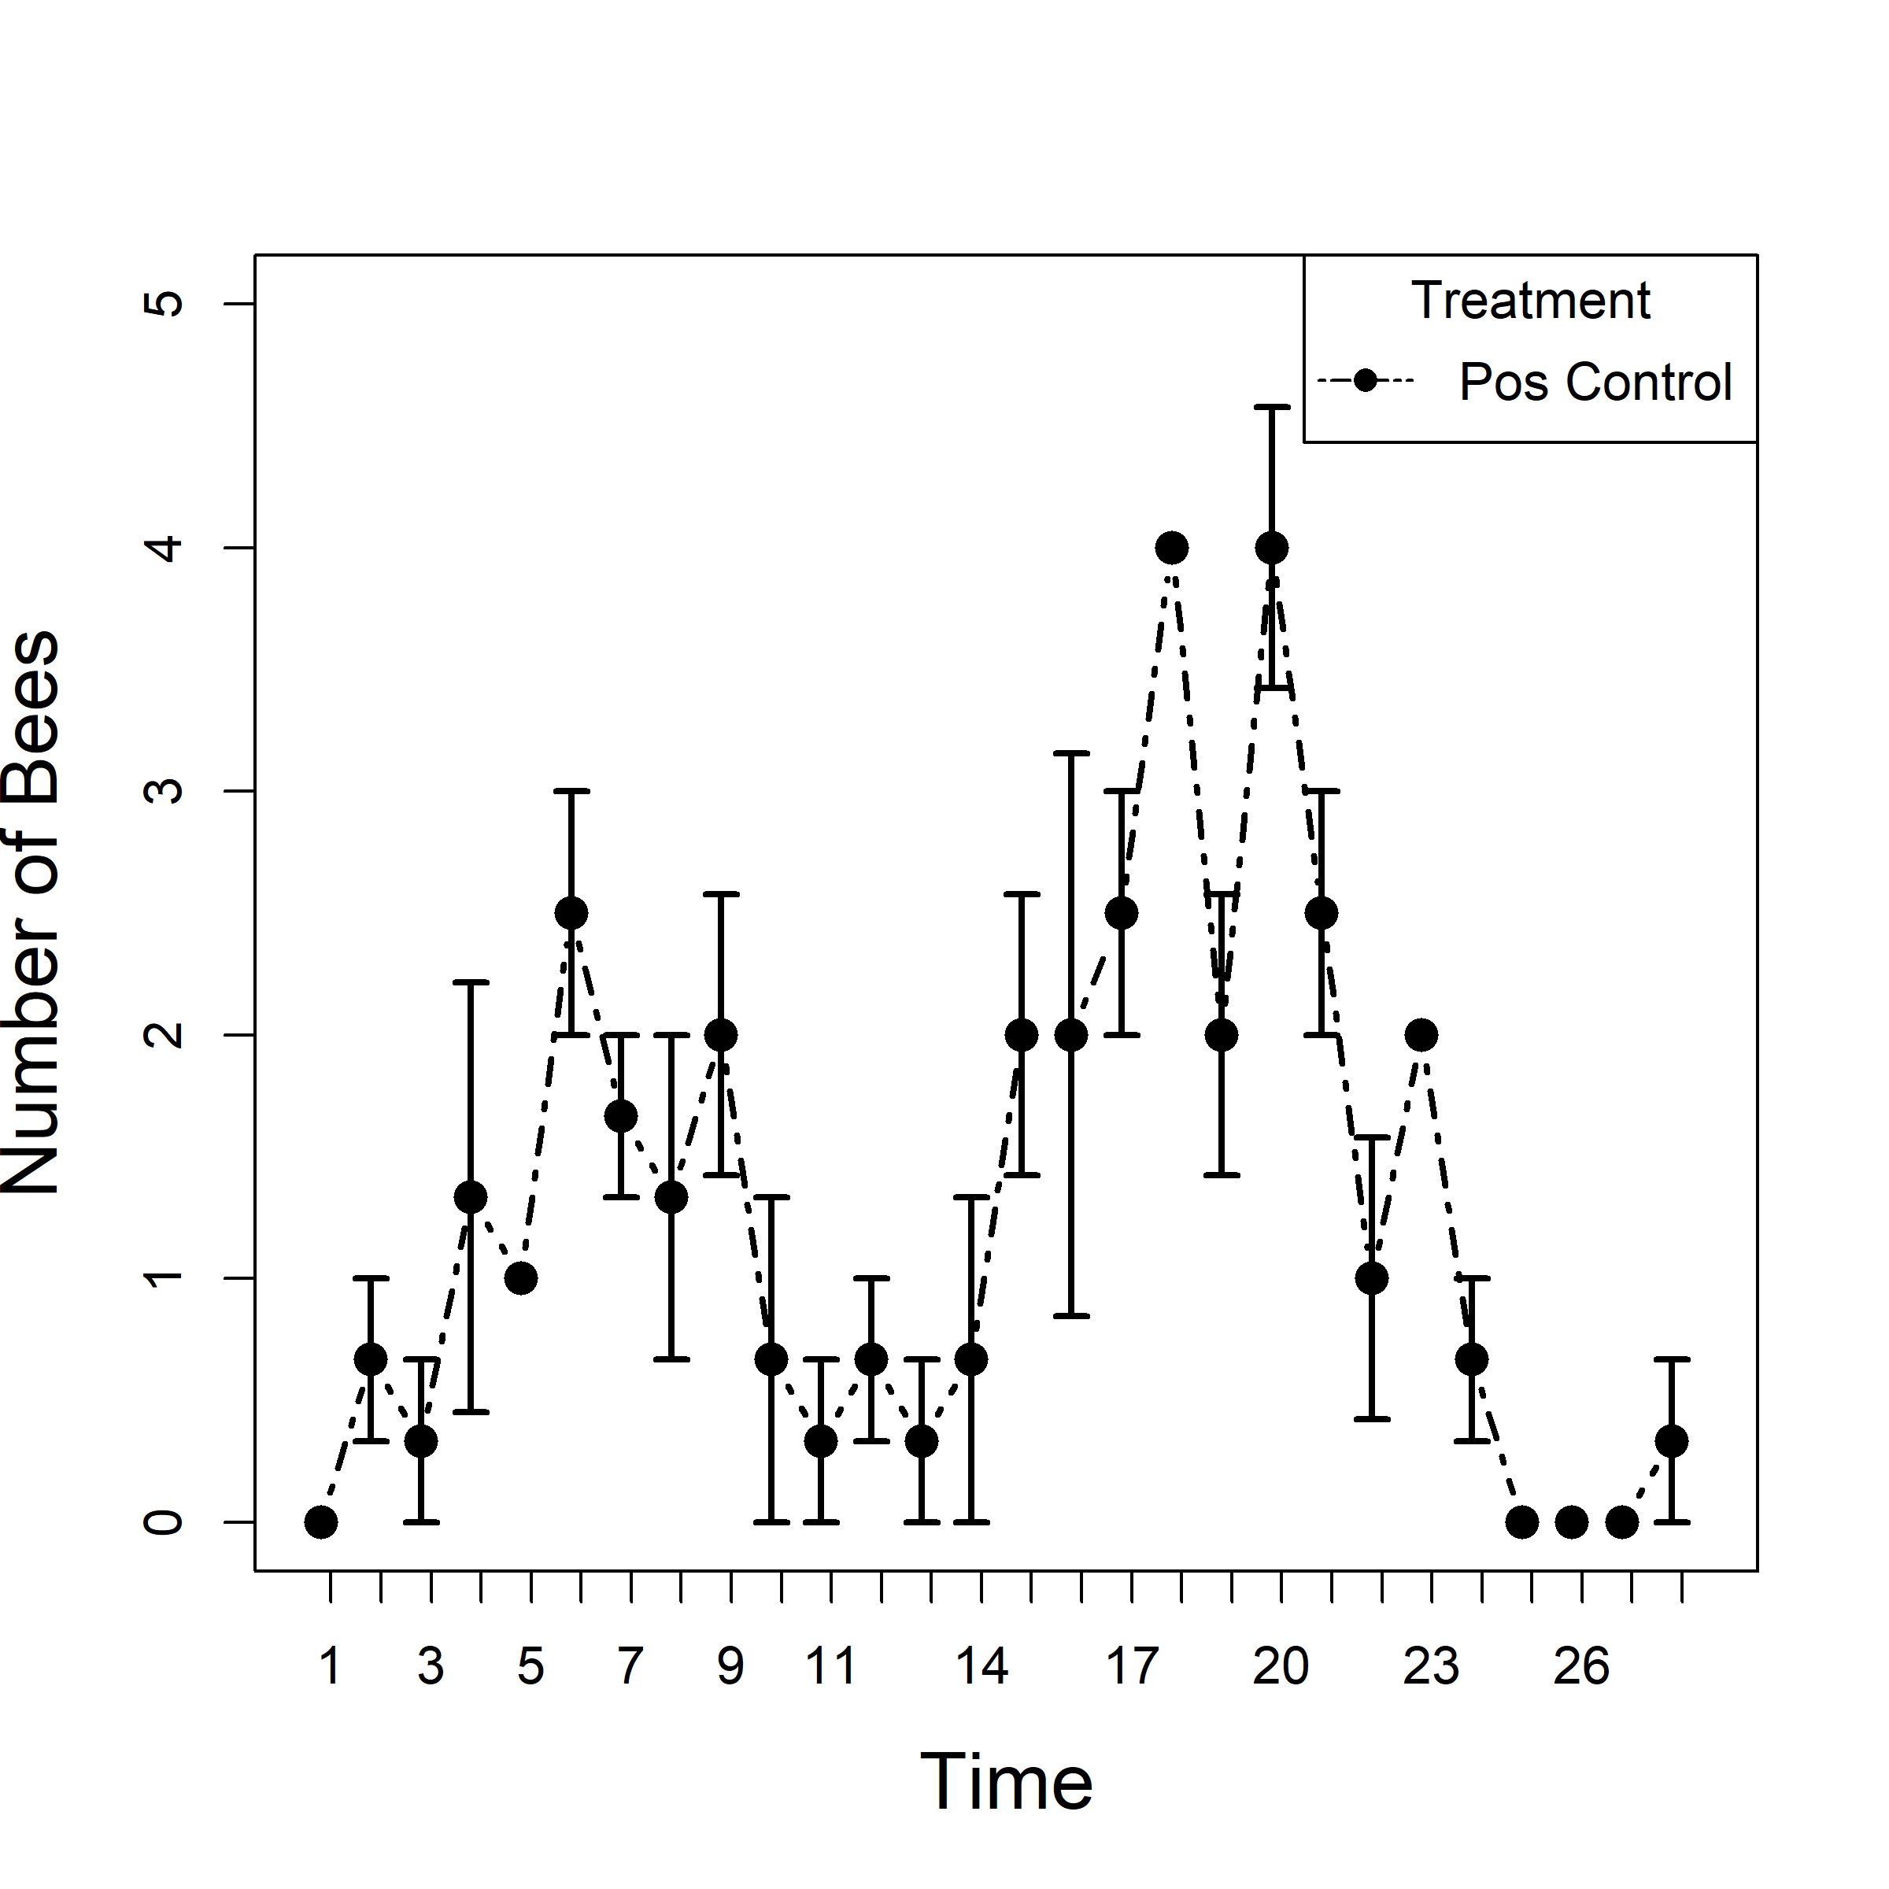
Figure 7: Positive control for number of bees observed.

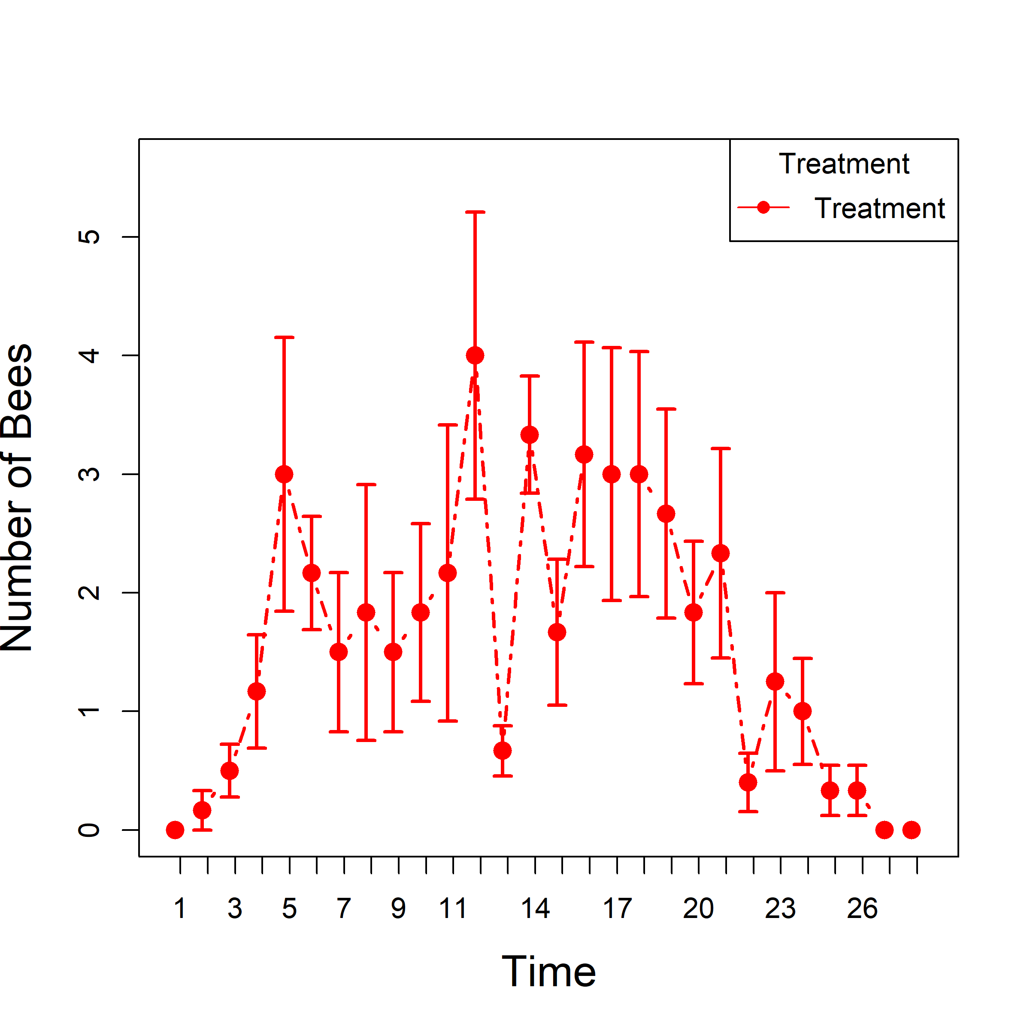
Figure 8: AP23 treatment for number of bees observed.

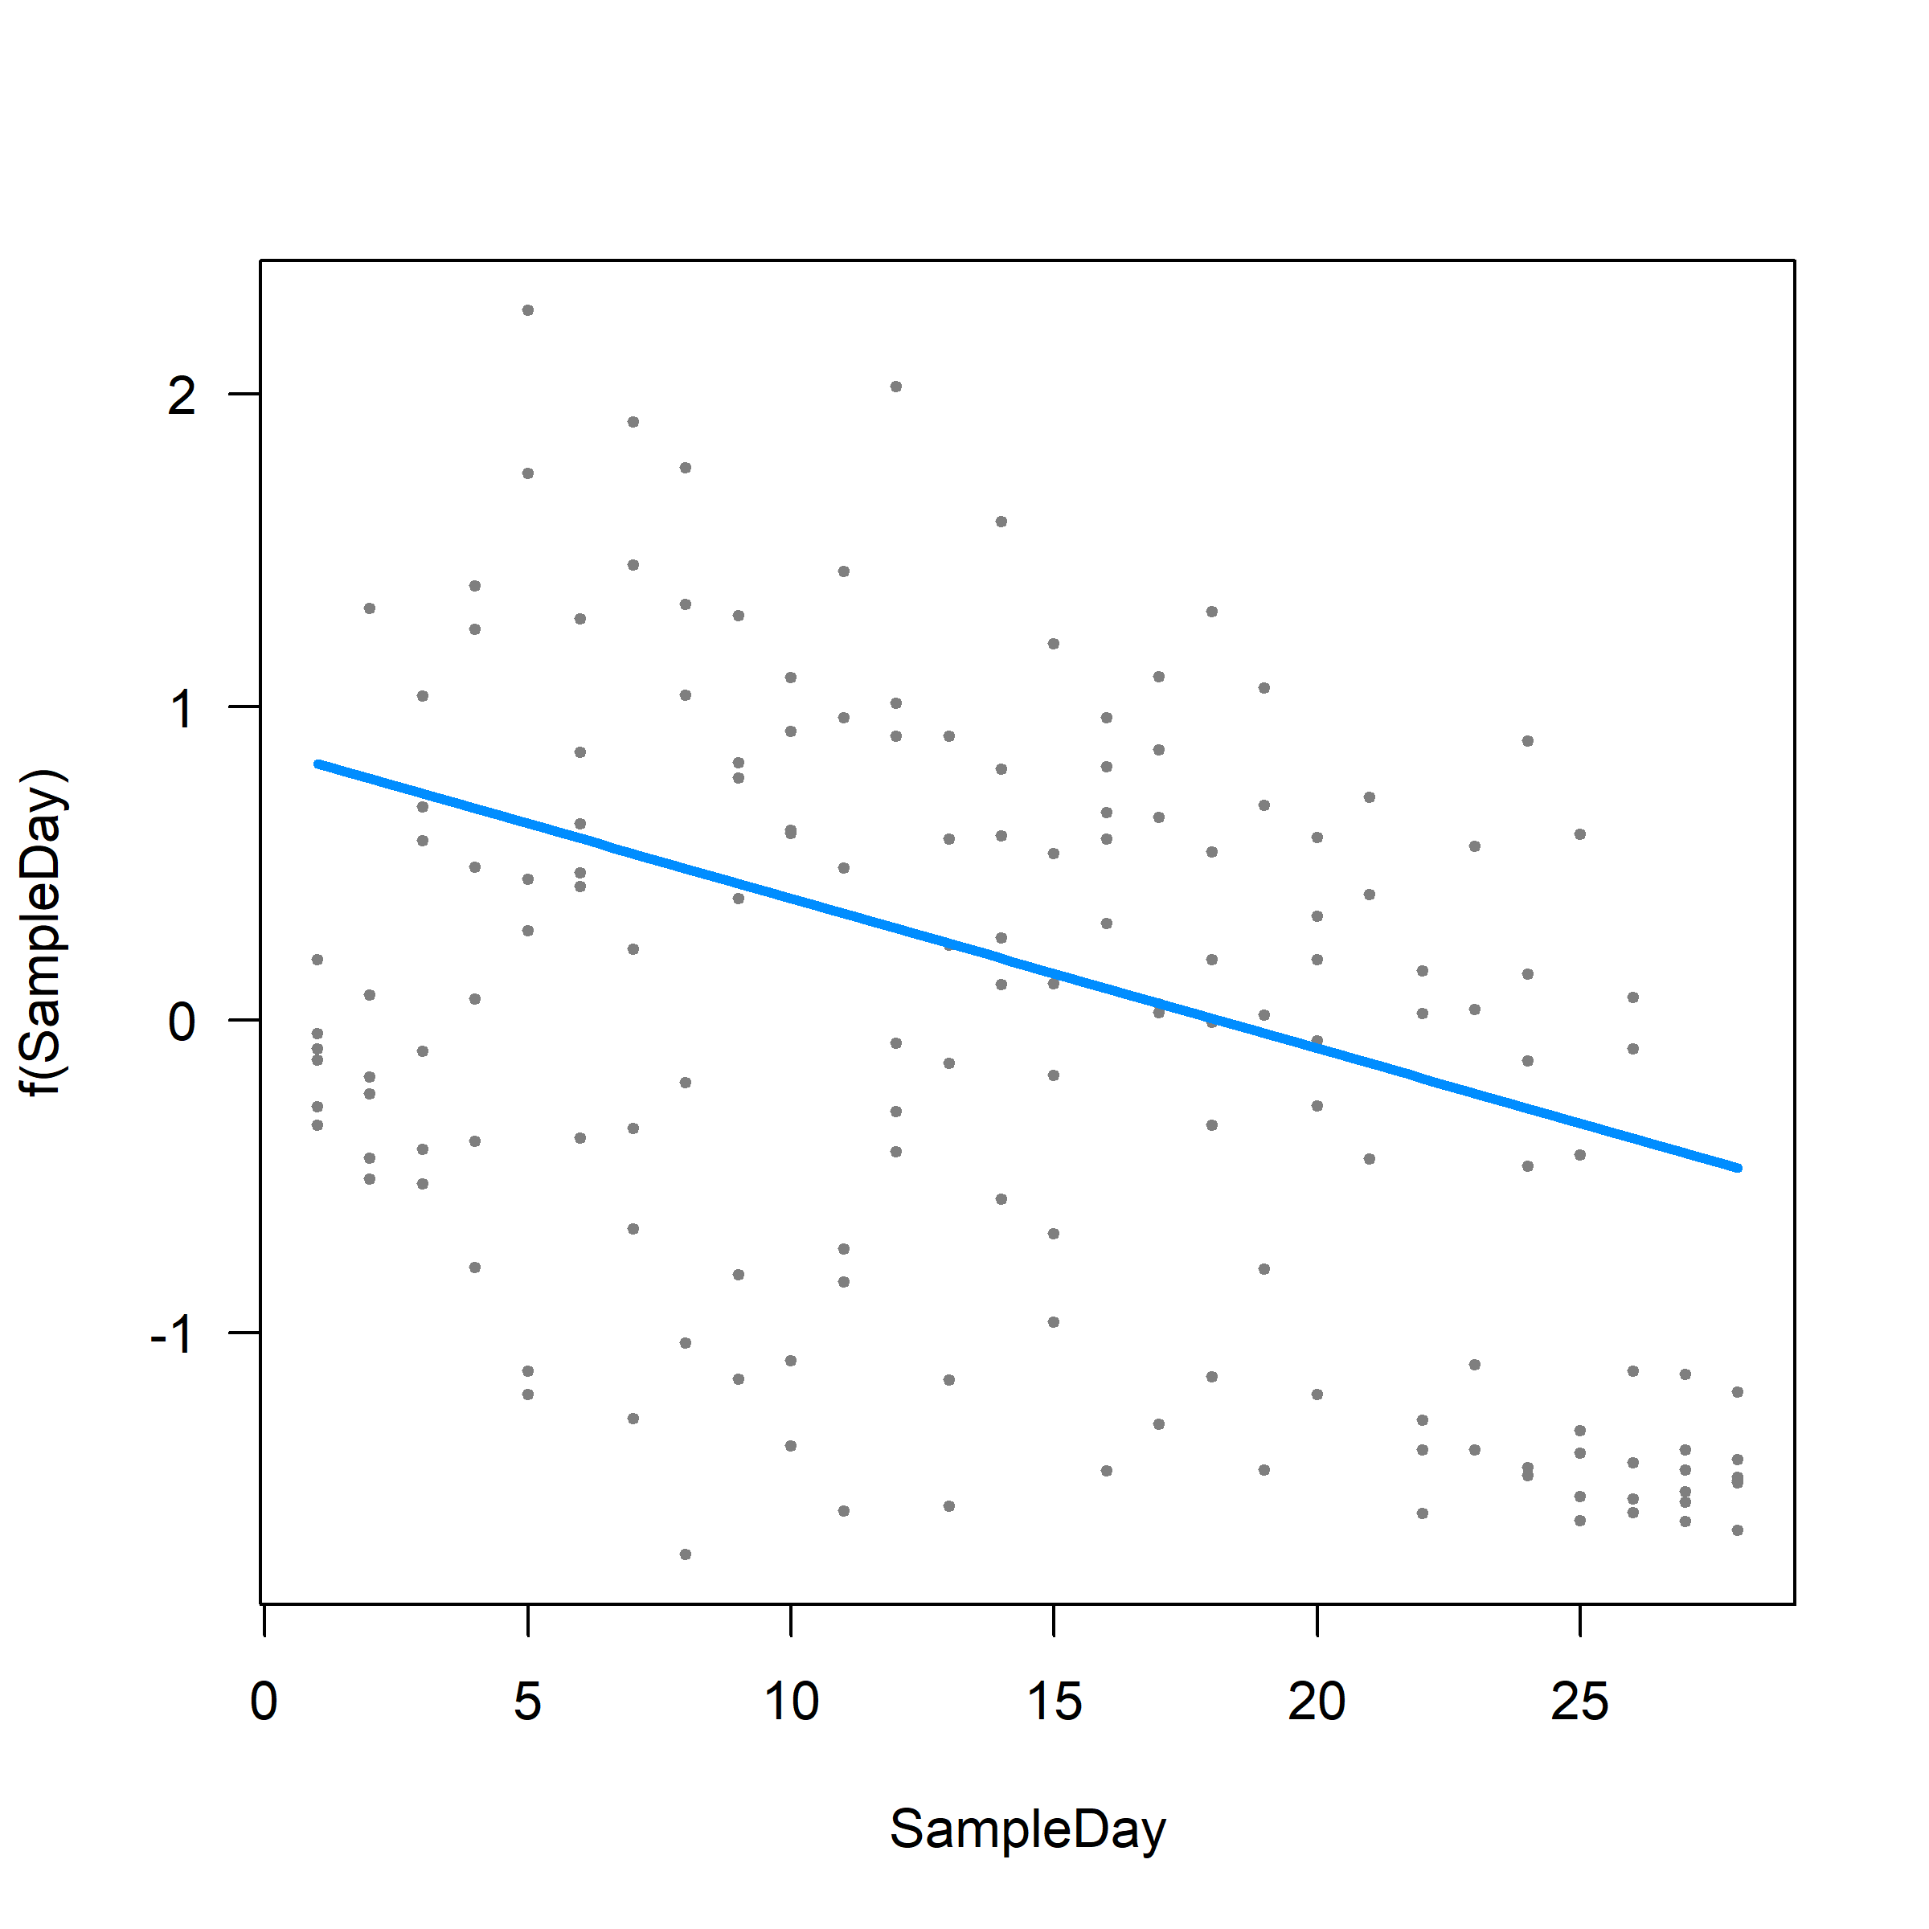
Figure 9: These graphs are a visualization of the model output. The models include area, colony, and the cumulative number of bees removed as random effects. Treating the sample day as a number, we see a significant overall downward trend in the number of bees counted by day.

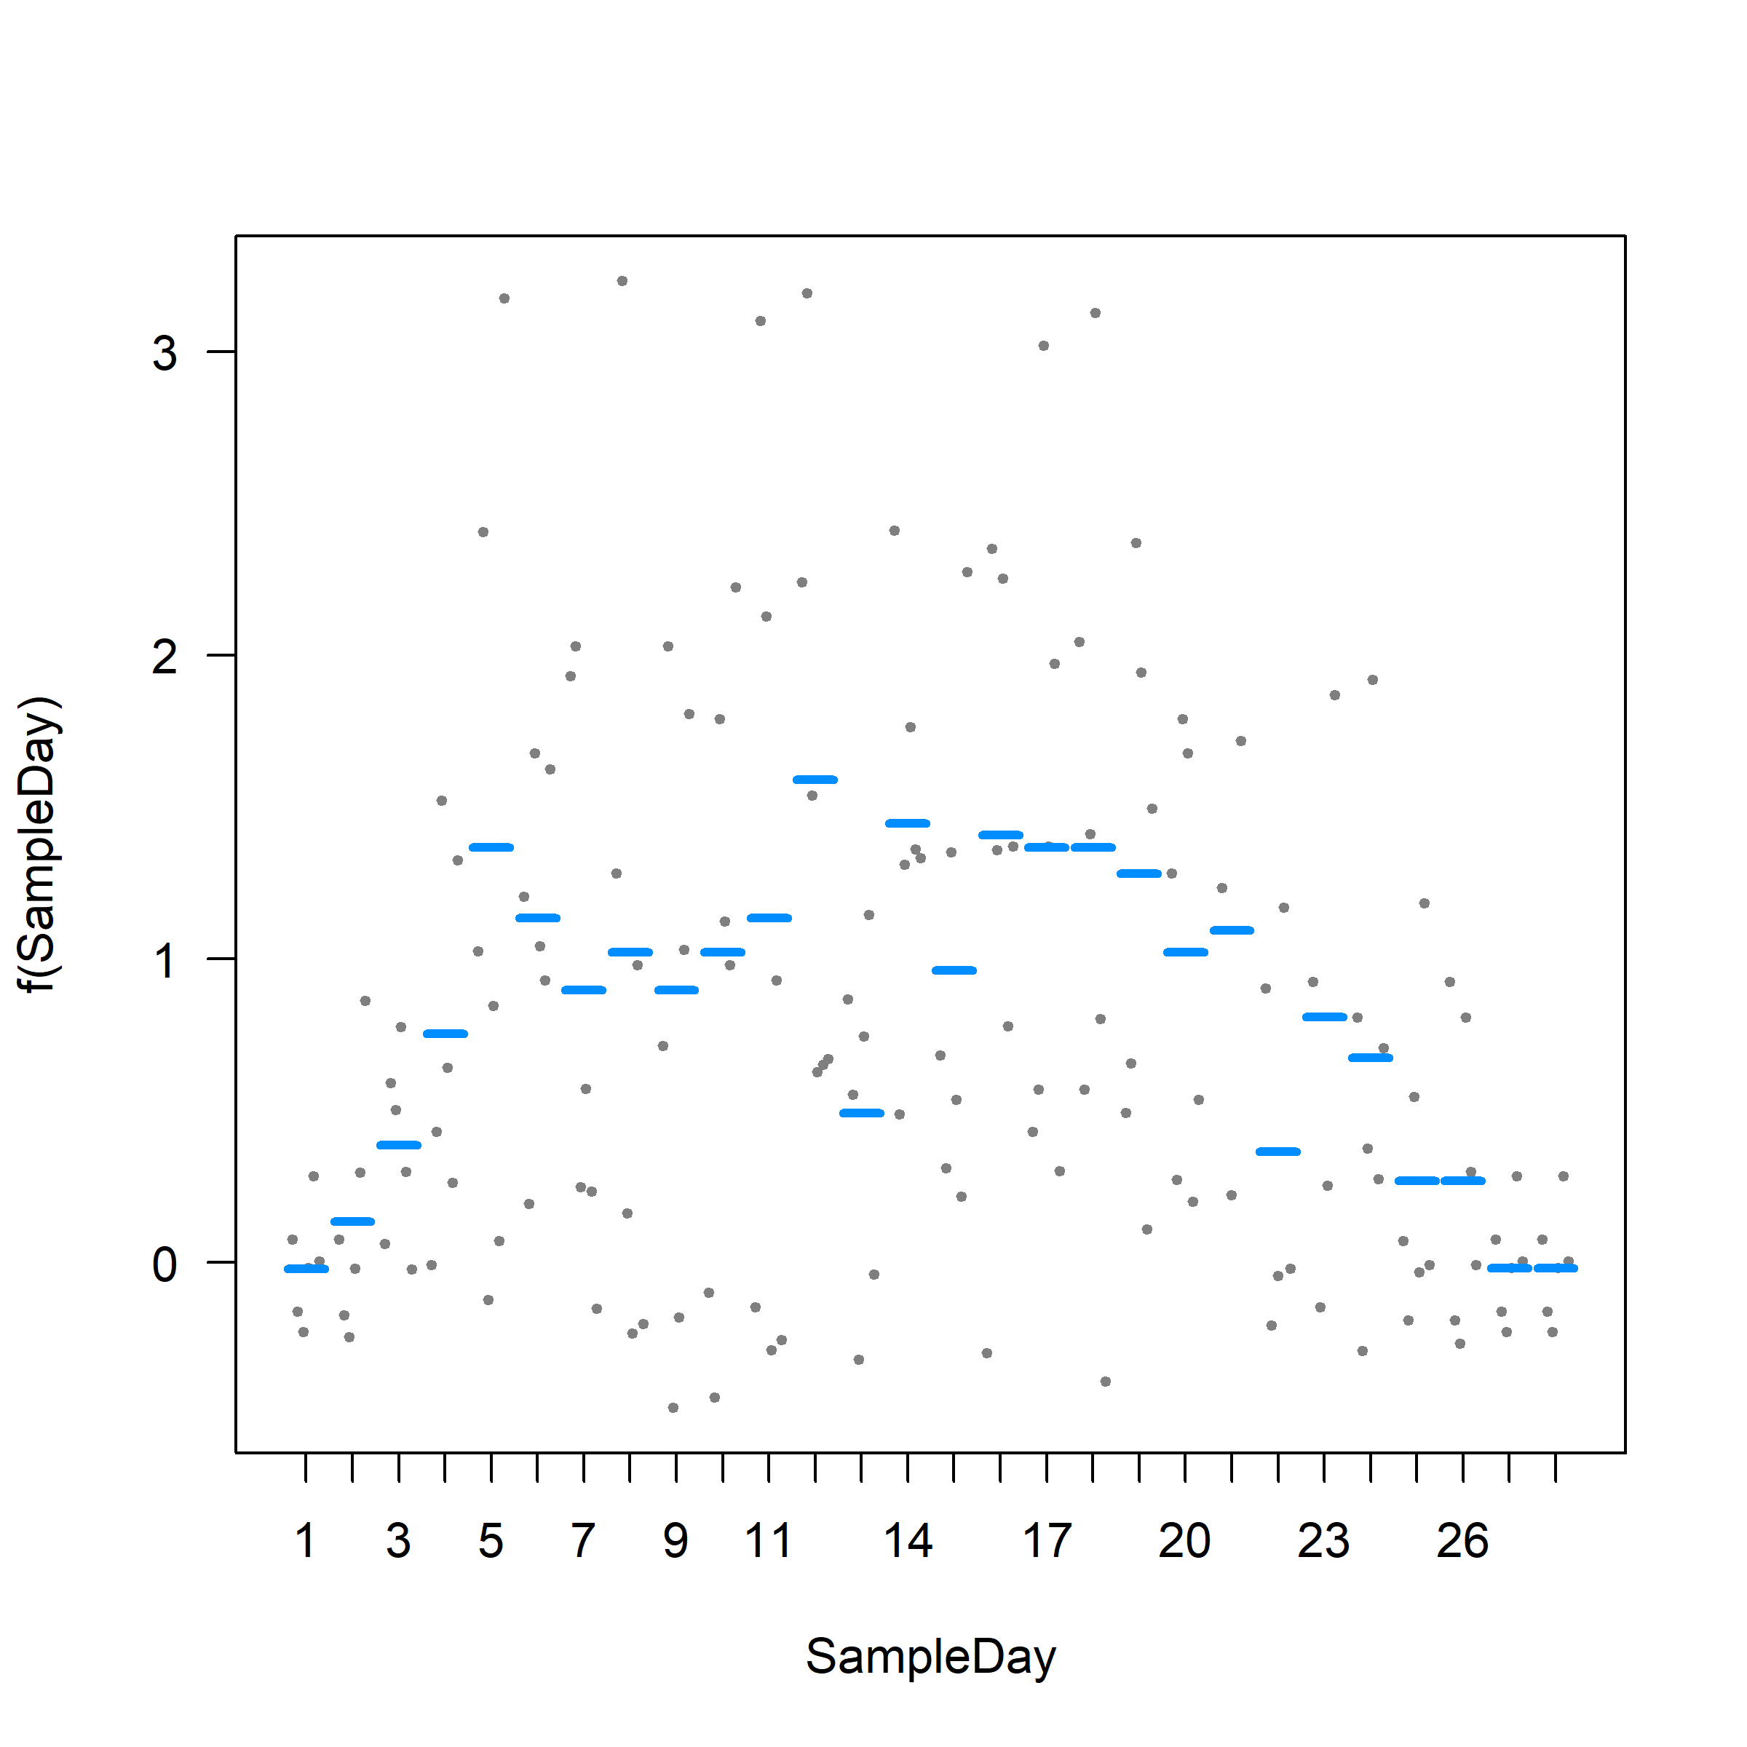
Figure 10: In contrast, treating sample day as a factor (1 is different from 2, but not smaller) shows the overall effect, where number of counted bees peak somewhere in the middle of the pack.

Takeaways
- Proportion of bees with dye was significantly higher in the treatment group than neg and cons. controls. Positive control had significantly higher proportion of bees with dye than all other treatments.
- Number of observed bees were significantly higher in the negative and positive controls and the AP23 treatment than the consumptive control.
- When subsetting to just get the treatment group, there was a significant effect of sample day in both response variables.
- Proportion of bees with dye seemed to increase until it peaked around day 21, whereas the number of bees counted consuming patties had more variability and peaked sooner.

